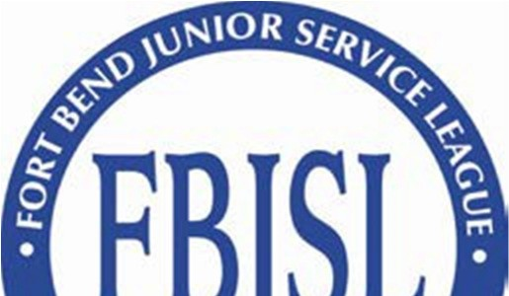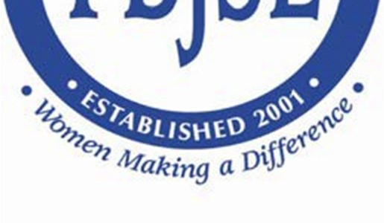

Fort Bend Junior Service League
P.O. Box 17387 • Sugar Land, Texas 77496 E-mail: brccom@fbjsl.com • www.fbjsl.com

Event Beneficiary Application

MISSION STATEMENT:
The Fort Bend Junior Service League is an organization of women committed to promoting volunteerism, to developing the potential of women and to improving the Fort Bend County community through the effective action and leadership of trained volunteers. Our purpose is exclusively educational and charitable as well as providing an atmosphere of friendliness, goodwill and camaraderie for all members.

Date Completed

Agency Name

Contact Person | Telephone Email Address
Mailing Address | Street Address
Website | Fax Number
Executive Director Telephone Email Address

Board Chair Telephone Email Address

Please check one of the following:

[ ] New Agency (An agency with no prior relationship with FBJSL)
[ ] Current or Prior Relationship Agency

Check all that apply and give dates and amounts:

[ ] CAF Recipient –
Date(s): Amount(s):
Date(s): Amount(s):
Date(s): Amount(s):
Date(s): Amount(s):
Date(s): Amount(s):

[ ] Event Beneficiary –
Date(s): Amount(s):
Date(s): Amount(s):
Date(s): Amount(s):
Date(s): Amount(s):
Date(s): Amount(s):

If you have received funds within the last five (5) years through FBJSL, have you submitted a Final Status & Expenditure Report for all funds received? YES or NO

If no, please explain below:

FINAL STATUS & EXPENDITURES REPORTS ARE DUE AUGUST 1ST
RECEIPT OF FUNDS FROM FBJSL. FSR SHOULD BE EMAILED TO BRCCOM@FBJSL.COM.

Please provide the following information about your agency and grant request.

NOTE: Funding will not be provided for insurance, individual projects, religious teachings or instruction, administrative costs/salaries and government or political programs. Funding will also not be provided for advertising or purchase of promotional materials for fundraising events. All funds must be used for direct services or items, for specific projects or needs, in the Fort Bend community.

- Please describe the Purpose/Mission of your agency:

- Please describe the Programs/Services provided by your agency:

- Please describe the geographic areas and client populations served by your agency including the approximate percentage of Fort Bend residents served:

- Amount Requested by your agency: Please provide a detailed description of your grant request including the specific project or needs for which the funds will be used. If funds are requested for multiple services or items, you must include a breakdown/budget of how those funds will be spent.

- Please provide the time frame for the use of funds requested, along with any information relating to a funding deadline for your agency’s request:

- Would your agency be willing to accept partial funding? What consequences, if any, to the project or program are anticipated if FBJSL can only partially fund your request?

Please include the following information with your completed application:
- Current annual operating budget
- Copy of most recent financial statements (audited, if available)
- Copy of current IRS determination letter indicating 501(c)(3) tax-exempt status, along with a statement on your organization’s letterhead signed by the Executive Director that there has been no change in the organization’s tax-exempt status
- Current list of Board of Directors
- If you have additional information or supporting documents related to your funding request (i.e. project budget, replacement cost estimate, etc.) that may be helpful to FBJSL in reviewing your application, please feel free to include it.
- You may include testimonies from your agency supporters and/or participants. Please limit to a maximum of three testimonies.

DISCLAIMERS:

By submitting an Event Beneficiary application, your agency is agreeing to notify FBJSL immediately in the event funding for the item(s) / project (s) requested is committed or received from another source.

If requested, applicant agrees to provide an authorized representative(s) from your agency to meet with the FBJSL Beneficiary Review Committee and/or FBJSL Board of Directors to present and discuss its application.

A Final Status & Expenditure Report (FSR) for funds received is due August 1, 2021. FSR should be emailed to brccom@fbjsl.com.

Application is hereby made this day of , 20 , for funds in the amount of $ on behalf of:

Official Name of Agency

Signature of Authorized Agency Representative

Printed Name Title

This application constitutes a contract as to how the funds are to be spent. Any funds not spent for the specific purpose stated in this contract must be returned to the Fort Bend Junior Service League

Thank you for applying for an Event Beneficiary grant from FBJSL

