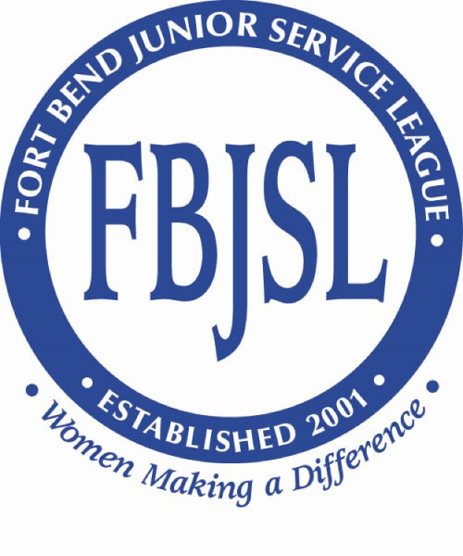
FBJSL Event Beneficiary Application Instructions

To be an eligible candidate for Event Beneficiary funding, organizations must have 501(c)(3) status and must be located in Fort Bend County, or the applicant must serve Fort Bend County residents. All applicants must meet the criteria set forth below in order to be eligible for grant funding. In addition to submitting your application, our Beneficiary Review Committee will request a meet with qualified candidates to discuss your application in more detail. Event Beneficiary Applications are due by June 1st.

Grant requests must align with the League’s mission, purpose, goals, and Position Statements. To qualify for a funding request, your organization’s mission must fall within one of the following statements:

EDUCATION
We support and promote quality education and are committed to using our resources to positively impact education.
HEALTH
We are committed to supporting quality and affordable health services, essential human services and comprehensive health education.
HOMELESSNESS
We support comprehensive services and efforts to address homelessness of all types.
PERSONS WITH DISABILITIES
We are committed to assisting persons with physical, mental and emotional disabilities, along with their caregivers.
VIOLENCE
We are committed to the elimination of violence by supporting programs and services designed to understand the problem of violence, to assist, educate and protect the victims.
The following grant requests shall not be considered:

- Projects sought by individuals
- Religious teachings or instruction
- Administrative costs or salaries
- Insurance
- Government or political agencies
- Nonprofit groups whose primary purpose is to fund government support entities
- Nonprofit groups who are not providing a direct service (i.e. foundations, exchange clubs, rotary clubs, etc.)

Please consider the above criteria when deciding whether or not to make your submission.

If you would like to apply to be an Event Beneficiary, please download the Event Beneficiary application, complete the information and send your completed application and the required supporting documents via email to brccom@fbjsl.com. All organizations must submit their grant applications via email.

