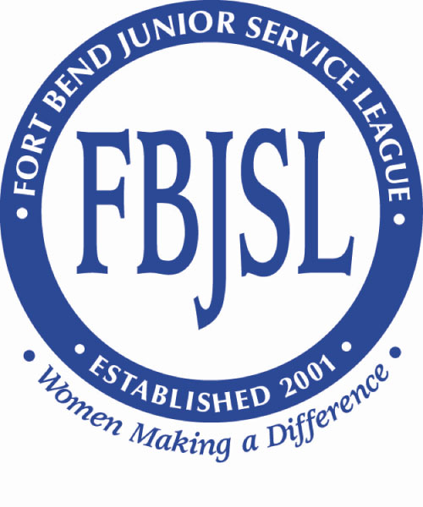
Fort Bend Junior Service League
P.O. Box 17387
Sugar Land, Texas 77496
www.fbjsl.org

Event Beneficiary
Final Status & Expenditure Report

Please complete and submit a copy of this Final Status & Expenditure Report (FSR) to brccom@fbjsl.com by August 1, 2023. An agency that fails to timely submit an FSR may not be eligible for future funding from FBJSL. A detailed accounting is required of the use and/or allocation of grant funds received from FBJSL.

_________________________________________________________________________
Agency Name

_________________________________________________________________________
Contact Person

_________________________________________________________________________
Phone FAX Email

_________________________________________________________________________
Mailing Address

_________________________________________________________________________
Physical Address (if separate)

_______________________________________________________________________
Website

_________________________________________________________________________
Executive Director Phone Email

_________________________________________________________________________
Board Chair Phone Email

Amount of grant received: Date received: ____________________

Have you received previous funding from FBJSL as an Event Beneficiary?
□ No
□ Yes
If yes, please indicate the name(s) and date(s) of the most recent five event(s):

__ Spring Fling (formerly Charity Ball)
__ Cookbook
__ Golf Tournament
__ Glitter & Gloss
__ Pancakes and Pajamas
__ Sugar Plum Market
__ Sugar Plum Marketplace - Virtual
__ Other ____________

Proceeds Received: Date(s) Received:

- $_______________ ______________
- $_______________ ______________
- $_______________ ______________
- $_______________ ______________
- $_______________ ______________

Summary: How did you use or allocate the grant funds received in December 2021?
Explain variances (if any) from your anticipated use or allocation of the funds, as outlined in your event beneficiary application.

Objectives: What did you want to achieve or accomplish with the proposed funds at the time of your application?

Strategies: What activities did you undertake to complete your objectives?

Outcomes: What was the result of this project? Were there any unexpected results?

Tools: How did you measure your impact? Please attach a sample of any evaluation tools used (surveys, questionnaires, etc.).

Sustainability: What is the future of this project?

Impact: How has the Fort Bend County community benefited from this project? How many people were served?

Demographics: What is the profile of the population served through this project (i.e. age, sex, socio-economic indicators, etc.)?

Accounting: Provide a detailed accounting of how the grant funds were used or allocated. In doing so, you should describe the specific expenses, or at least categories of expenses, funded as part of the project (i.e., $3,000 towards 3 new desktop computers, $7,500 towards 750 hours of therapy for disabled children, etc.). If this form does not allow enough space, you may instead attach an accounting. You may also attach invoices or other documentation that may be helpful in showing the funds were properly used or allocated.

Project Expenses | FBJSL Funds | Other Funds | Total Funds
Total Expenses

_______________________________________________________________________
Signature Date

_______________________________________________________________________
Name Title

