FBJSL Volunteer Scholarship Overview

What is the Fort Bend Junior Service League?
The Fort Bend Junior Service League (FBJSL) is a non-profit organization of women committed to promoting volunteerism, to developing the potential of women and to improving the Fort Bend County community through the effective action and leadership of trained volunteers. Our purpose is exclusively educational and charitable as well as providing an atmosphere of friendliness, goodwill, and camaraderie for all members.

What is the purpose and the amount of the FBJSL Volunteer Scholarship?
The scholarship is established to support the volunteer potential of our youth by awarding a
scholarship grant in the amount of $1,000.00 to a female high school senior demonstrating outstanding volunteer performance within the community.

What are the requirements to qualify for a FBJSL Volunteer Scholarship? Applicant must be a female graduating from a Fort Bend County public or private high school in Spring 2023. Applicant must have a cumulative grade point average of 2.5 (C) or better. A transcript must be submitted with the application. Applicant must have completed at least 100 hours of volunteer service during high school. Volunteer service means service to the community through a non-profit organization benefiting the residents of Fort Bend County or volunteer service performed through school activities, excluding any service performed as a requirement for school or church. A letter(s) from the person(s) supervising the volunteer activities verifying the hours must be provided with the application.

Applicant must submit an essay with the application. This essay must be double spaced and no more than 500 words.
Scholarship award must be used for continuing education at an accredited college or university during the 2023-2024 academic year.
Members of FBJSL, including Fort Bend Teen Service League, and their family members are ineligible to apply for a FBJSL Volunteer Scholarship.

When are decisions made?
The evaluation process will take place through March. An acknowledgment will be sent to each applicant upon receipt of her application and at the conclusion of the evaluation process. Each scholarship recipient will be notified in March and invited to attend the FBJSL General Meeting in April for a presentation. Checks will be sent by FBJSL to the recipient’s chosen school upon receipt of written verification of enrollment/registration/payment instructions from the recipient. If the recipient decides not to attend an accredited college or university, or vocational school in the fall, she will forfeit her scholarship award. If payment instructions are not received by FBJSL by May 15, 2023, FBJSL reserves the right to revoke her scholarship award.

Will there be an interview?
Applicants may be asked to interview with the Beneficiary Review Committee. If the Committee decides to conduct interviews, interviews will take place during the month of March.

Where can I get a copy of the application and who do I contact if I have questions?
You can download the application from the FBJSL website at www.fbjsl.org.

Where do I send my application?
Applications and required supporting documents must be sent via email to brccom@fbjsl.com

When are applications due?
Applications are due FEBRUARY 1, 2023.

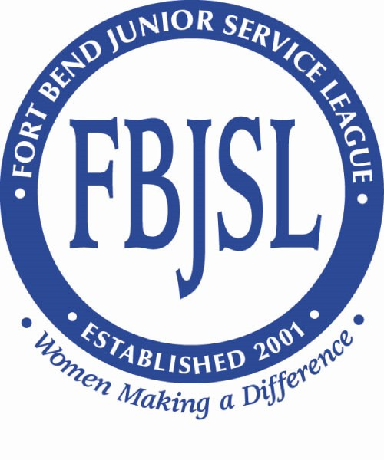
Fort Bend Junior Service League
Volunteer Scholarship Application
Due Date: FEBRUARY 1, 2023

Personal Information

Name:

Parent or Guardian with whom you reside:

Address:

Cell Phone:

Date of Birth: Email Address:

Are you a dependent of and/or related to a past or present FBJSL member? No
If you answered yes, please list name of member:

How did you learn about this Scholarship opportunity?

School Information

High School Currently Attending:

Address:

Counselor’s Name: Telephone:

Cumulative Grade Point Average (4-point scale Grades 9th-12th):

List colleges that you have applied for or been accepted to (attach acceptance letter, if applicable).

Name of Institution Date of Acceptance

Volunteer Experience

List volunteer organizations you have worked with. Please do not include any volunteer work completed as a requirement for school or church.

Dates Worked | Agency Name | Description of Responsibilities | Total # of  Volunteer Hours:
Total Number of Volunteer Hours:

Leadership Roles
Explain leadership positions you have held in high school, volunteer organizations and/or extracurricular activities.

Awards & Recognition
Please summarize any awards and/or recognitions you have received in your high school, volunteer, extra-curricular, and/or employment activities.

Employment
Please list places of employment, if any. Please also provide the Supervisor’s name, email address, and phone#.

Essay
Please submit an essay addressing these questions and any other information about yourself that the committee should consider. The essay should be double spaced and no more than 500 words.

- How & why did you become involved with volunteer work?
- What have you gained/lost from being a volunteer?
- How has your volunteer work influenced/shaped your educational, career, and/or your life goals?
- What are your future goals/plans for volunteering?

I affirm that the information provided in this application is true and complete to the best of my knowledge. I consent to the verification of information contained in my application.

_________________________________________ ____________________________________
Signature of Applicant Date

Fort Bend Junior Service League Volunteer Scholarship Application
Supervisor Recommendation Form

Name of Student:

Name of Supervisor:

Title of Supervisor:

Agency:

Address:

Telephone:

Because of a belief in volunteerism and the important contributions volunteers make to improve communities, the Fort Bend Junior Service League established a scholarship award based on the volunteer performance of high school youth. Awards of $1,000.00 will be granted annually to up to six (6) female high school seniors demonstrating outstanding volunteer performance.

As a supervisor of this student’s volunteer work, please answer the following questions. Attach additional pages if necessary.

- During what period did this student work under your supervision?

- How many hours of volunteer work did this student perform?

- What duties did this student perform?

- Please explain what made this student’s service unique and worthy of recognition of a volunteer scholarship award. Please use a separate sheet of paper if necessary.

Signature: _________________________________________
Date: ______________________________________________

